**UNIVERSITY OF MINES AND TECHNOLOGY**

**TARKWA**

FACULTY OF GEOSCIENCES AND ENVIRONMENTAL STUDIES

DEPARTMENT OF GEOMATIC ENGINEERING

A PROJECT REPORT ENTITLED

**A 3D COORDINATE TRANSFORMATION SOFTWARE BASED ON BURSA WOLF MODEL**

SUBMITTED IN PARTIAL FULFILLMENT OF THE REQUIREMENT FOR THE AWARD OF THE DEGREE OF BACHELOR OF SCIENCE IN GEOMATIC ENGINEERING

BY

**KANGAH DESMOND**

PROJECT SUPERVISOR

……………………………………

**DR. Y. Y. ZIGGAH**

TARKWA, GHANA

SEPTEMBER 2022

# **DECLARATION**

I declare that this project work is my own work. It is being submitted for the degree of Bachelor of Science in Geomatic Engineering in the University of Mines and Technology (UMaT), Tarkwa. It has not been submitted for any degree or examination in any other University.

………………………………………………

(Signature of candidate)

Submitted this ……………….…………day of ….…………Year.

# **ABSTRACT**

All countries can use satellite positioning systems like the Global Positioning System (GPS) for geospatial positioning. The accessibility of such positioning techniques has transformed surveying in Ghana. To use the non-geocentric Ghana War Office 1926 datum instead of the satellite based WGS84 datum, coordinates must be transformed. Therefore, a functional connection between these two dissimilar reference frames must be established. This study aims at performing a coordinate transformation between War Office 1926 and WGS84 datums based on the Bursa Wolf model and develop software to compute all the transformation parameters and use those parameters to project local geodetic coordinates onto Ghana's preferred projection, the Transverse Mercator. Common points used for the transformation between War Office 1926 and WGS84 coordinates in the form of longitude, latitude, and ellipsoidal height were obtained from the Survey and Mapping Division. The transformation model with the software produced Root Mean Square Horizontal Error (RMSHE), Arithmetic Mean of the Horizontal Error (AMHE) and Standard Deviation (SD) values of 2.89365802 m, 2.458279232 m and 2.50194×10-9 m, respectively.

# DEDICATION

I dedicate this work to my parents Mr and Mrs Kangah, my senior brother Justice Kangah.

# ACKNOWLEDGEMENT

I am much grateful to God for his endless love for me throughout my stay in this University and for strengthening me in all my endeavors till this day. I want to give a special thanks to my noble supervisor Dr. Y. Y Ziggah for the support, supervision, and motivation. To my parents, my senior brother, and the entire family, I am grateful for the opportunity given to me. I am grateful once again to Dr. Emmanuel Effah for the opportunity he gave me and his advice. Thank you to all the friends I have made in this university and those outside who in various ways have contributed to my success especially John Agbelengor my study mate for the motivation and everything. I also thank Mr. Japheth Blankson for his guidance throughout my project.

# **TABLE OF CONTENTS**

DECLARATION i

ABSTRACT ii

DEDICATION iii

ACKNOWLEDGEMENT iv

TABLE OF CONTENTS v

LIST OF FIGURES vii

LIST OF TABLES viii

CHAPTER 1 1

INTRODUCTION 1

1.1 Statement of Problem 1

1.2 Project Objectives 2

1.3 Methods Used 2

1.4 Facilities Used 2

1.5 Organisation of Report 3

CHAPTER 2 4

THE STUDY AREA 4

2.1 Location and Size 4

2.2 Geodetic System of the Study Area 4

2.3 Geodetic System of Study Area 5

CHAPTER 3 8

LITERATURE REVIEW 8

3.1 Review of Geodesy 8

3.2 Datum 8

3.2.1 Horizontal Datum 9

3.2.2 Vertical Datum 9

3.3 Benchmark Surface 10

3.3.1 The Geoid 10

3.3.2 The Ellipsoid 11

3.4 Coordinate System 14

3.4.1 The Geodetic Coordinate System 15

3.4.2 Geocentric Coordinate System 15

3.5 Coordinate Transformation 16

3.5.1 Transformation Models and Procedures 17

CHAPTER 4 18

MATERIALS AND METHODS 18

4.1 Source of Data 18

4.2 Softwares Used 18

4.3 Methods Used 18

4.3.1 C-Sharp Language (C#) 20

4.3.2 Forward Conversion 20

4.3.3 Bursa – Wolf Transformation Model 22

4.3.4 Reverse Conversion 23

4.3.5 Bowring Inverse Equation 23

4.3.6 Transverse Mercator Projection 25

4.3.7 Software and the Model Performance criteria 27

CHAPTER 5 29

RESULTS AND DISCUSSION 29

5.1 Software Architecture 29

5.2 Data Results 32

5.2.1 Revise Conversion and Projected Coordinates 34

5.3 Model Adequacy Assessment 36

CHAPTER 6 37

CONCLUSIONS AND RECOMMENDATIONS 37

6.1 Conclusions 37

6.2 Recommendations 37

REFERENCES 38

# **LIST OF FIGURES**

**Figure Title Page**

Table 2.1 Source Data and Target Data 7

Figure 3.1 Ellipsoid, Geoid, and the Topographic Surface 10

Figure 3.2 Geoid (Source: Bob, 2012) 11

Figure 3.3 A Diagram of the Earth's Reference Ellipsoid 12

Figure 3. 4 The Geocentric coordinate system (Source: Ziggah, 2021) 16

Figure 4. 1 Flow Chart of Methods Used 19

Figure 4. 2 Ellipsoidal Surface 20

Figure 4.3 Geometry of Bursa – Wolf Model 22

Figure 4. 4 Relationship between the Center of the Curvature and the Meridian. 24

Figure 5. 1 Software Ground Interface to upload data 29

Figure 5.2 GUI Showing uploaded Latitude, Longitude, and ellipsoidal height data 30

Figure 5. 3 GUI for Forward Conversion 30

Figure 5.4 GUI of Transformation Parameters and Geodetic to Cartesian Coordinate 31

Figure 5.5 GUI view for Projection of Coordinate to Transverse Mercator 32

Table 5.2 Cartesian Coordinates from WGS84 and War Office Ellipsoid 33

Table 5.3 Parameters from Bursa Wolf Transformation Model 34

Table 5.4 Projected Coordinates and Known Coordinates with their Errors 35

Table 5.5 Summary Statistic Results 36

# **LIST OF TABLES**

**Table Title Page**

Table 2.1 Source Data and Target Data 7

Table 5.2 Cartesian Coordinates from WGS84 and War Office Ellipsoid 33

Table 5.3 Parameters from Bursa Wolf Transformation Model 34

Table 5.4 Projected Coordinates and Known Coordinates with their Errors 35

Table 5.5 Summary Statistic Results 36

# **CHAPTER 1**

# **INTRODUCTION**

## **Statement of Problem**

An epochal revolution of science and technology has broken the geographical restrictions of traditional surveys and has ushered into a new era of modern surveying. The Global Navigation Satellite Systems (GNSS) is one of the most important discoveries that science and technology has brought to the geoscientific community owing to its global coverage and open access (Ziggah, 2016). GNSS make use of coordinate system. A coordinate system is an abstract way for determining coordinate or positions in space such as in relation to an ellipsoid, curvilinear geographic or local topocentric coordinates (Ziggah, 2021). The most prevalent coordinate system is the system of latitudes, longitudes, and ellipsoidal heights (Ayer and Fosu, 2008).

The situation with this system is compounded by the fact that this system of same point fluctuates significantly depending on the country’s geodetic system, resulting in differences in the coordinates (Ayer and Fosu, 2008). Typical example is integrating GPS coordinate into a country’s mapping system, and this will need mathematical computations. Similarly, measuring distances from a graticule map without appropriate projection conversion is impossible. Such issues arise in a variety of contexts, including map revision, cadastral, deformation studies, etc. (Mitsakaki, 2004). To use the data obtained from GPS measurements correctly and effectively in Ghana, appropriate transformation parameters that relate the Ghana National Survey Mapping coordinate system to that used for the GPS must be used to transform the coordinates (Ayer and Fosu, 2008).

Determining appropriate parameters involves coordinate transformation. Depending on the requirements, coordinate transformation can be three-dimensional (3D), two-dimensional (2D), or even one-dimensional (1D), (Ziggah, 2021). There are several models used for coordinate transformation worldwide. Bursa-wolf model stands as the commonest practical mathematical approach for coordinate transformation that has been widely used in Ghana frame (Kumi-Boateng and Ziggah, 2016). This is because the shape of the geodetic network containing the coordinates to be converted is retained, angles are not changed after transformation, but there are differences between modified coordinates and their original places (Ziggah *et al.,* 2019). Bursa-Wolf uses seven parameters to create a mathematical formula for transforming two reference frames in a 3D cartesian coordinate system. The seven parameters are made up of three translations on the X, Y and Z axes, three rotations on the axes and one scale factor. These parameters create a common origin, makes the reference axes of the two systems parallel, and create equal dimensions in the two systems, respectively.

The problem now is how these parameters can be computed with ease and use for coordinate transformation because all the research works done focuses on running a script which cannot be easily done by a normal person without coding skills. This project developed a software that computes the desired transformation parameters for an input system based on the Bursa-Wolf Transformation Model.

## **Project Objectives**

The objectives of the project are to:

1. Carry out a coordinate transformation between war office 1926 and WGS84 datums; and
2. Develop a software for 3D coordinate transformation.

## **Methods Used**

The methods used include the following:

1. The various methods shall be coded as a computer algorithm in C# (C-sharp language) using visual studio environment;
2. Bursa-Wolf transformation model; and
3. Statistical evaluation of the transformation results using horizontal positional shift, root mean square error, and standard deviation.

## **Facilities Used**

The facilities used for the project include:

1. Library and Internet facilities from UMaT;
2. MATLAB 2021a from the Geomatic Engineering Department; and
3. Visual studio 2019 from the Geomatic Engineering Department.

## **Organisation of Report**

The report is in six (6) chapters. The first chapter is the introductory chapter. It introduces the project topic, the problem statement of the project, the objectives of the project, the expected outcomes of the project, methods and materials used and the organization of the report. The second chapter deals with the relevant information about the study area. The third chapter reviews the literature related to the topic. The fourth chapter deals with the methods and materials used in the project. The fifth chapter presents and discusses the results obtained. The sixth and final chapter concludes the report by giving a summary of the report and also making relevant recommendations for future utilisation of the information gathered.

# **CHAPTER** **2**

# **THE** STUDY AREA



## **Location and Size**

Ghana is a nation in western Africa that is in the northern hemisphere, above the equator. Located halfway between the eastern and western hemispheres is the nation. The Atlantic Ocean and Gulf of Guinea, as well as the nations of Burkina Faso, Cote d'Ivoire, and Togo, all abut Ghana. According to Mugnier (2000), Ghana's approximate total land area is 238.540 km2, of which 227.533 km2 is land and 11 000 km2 is water. According to Baabereyir (2009), the country is located between latitudes 40 30' N and 110 and longitudes 30 W and 10 E above the equator. The territory is primarily composed of flat plains, with a dissected plateau in the south-central region and isolated places of high relief (Mugnier, 2000).

## **Geodetic System of the Study Area**

According to historical evidence, Captain F.G. Gordon Guggisberg, the then-Government of the Gold Coast Colony, now Ghana, started the country's geodetic survey in June 1904. The Governor used a zenith telescope to make latitude observations from a pillar in the compound of the Secretary of Native Affairs' home in Accra, which resulted in a final probable azimuth inaccuracy of 0.360" (Poku-Gyamfi, 2009). Through the transmission of telegraphic signals with Cape Town, South Africa, in the months of November and December of that same year, Geographic Coordinates System (G.C.S). 547's longitude was established (Mugnier, 2000). Although the influence of local attractions was noted in the observations after further works, the G.C.S. 547 (Accra), which had latitude 50 23' 43.33" N and longitude 00 11' 52.3" W, was selected as the basic latitude and longitude for the then Gold Coast Colony. Figure 2.1 shows the map of the study area.

**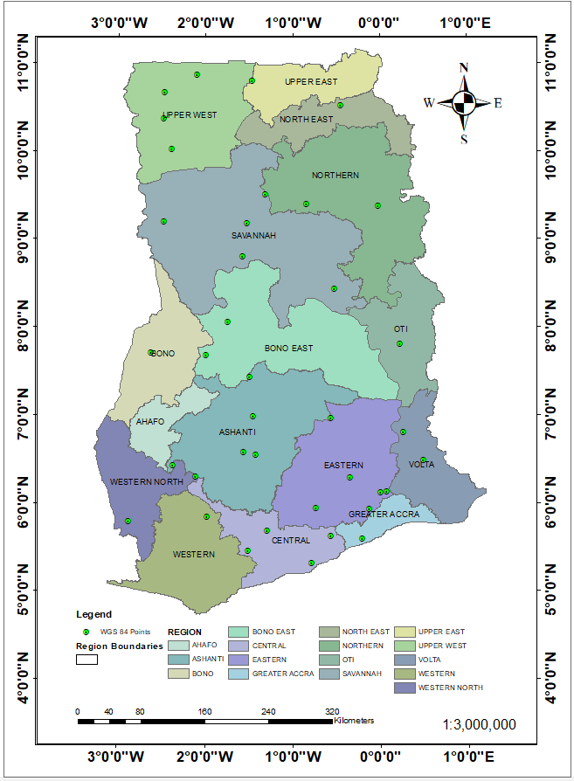****Figure 2.1 The Study Area of the Project**

## **Geodetic System of Study Area**

Ghana has two national horizontal geodetic datums namely, the Leigon and the Accra datum which was realized because of Astro-geodetic observations (Mugnier, 2000; Ayer and Fosu, 2008; Poku-Gyamfi, 2009). These served as the foundation for calculating geographic coordinates and selecting the War Office ellipsoid from 1926 as the country’s best local fit ellipsoid. The local realization of the War Office 1926 ellipsoid is the Accra datum 1926 by the British War Office while the legion datum is based on the Clark 1880 (modified) ellipsoid (Ayer, 2008; Ayer and Fosu, 2008). The semi-major axis a = 6 378 299.99899832 m, flattening f = 1/296, and semi-minor axis b = 6 356 751.68824042 m are the ellipsoid characteristics that the British War Office calculated for the War Office 1926 ellipsoid (Poku-Gyamfi, 2009; Ayer, 2008; Ayer and Fosu, 2008). It was eventually discovered that a more practical system than geographic coordinates was required for the purpose of surveying and mapping. This led to the adoption of a plane rectangular coordinate system on the Transverse Mercator (TM) projection (Mugnier, 2000; Poku-Gyamfi, 2009). Ghana’s adopted Transverse Mercator projection has longitude 10 00’ W as its central meridian having latitude 40 40’ N. False Easting value of 274 319.736 m was added to all Y coordinates with False Northing set to zero to prevent the creation of negative coordinates. It was discovered that a scale factor of 0.99975 was more suitable at the centre meridian (Kumi-Boateng and Ziggah, 2020).

The Ghana Survey and Mapping Division of the Lands Commission initiated the Land Administrative Project (LAP) with assistance from the World Bank and other partners for Ghana to take advantage of the capabilities of GNSS technology. One of the LAP's primary objectives is to establish a nationwide GNSS reference network for Ghana. The LAP contains three phases the Golden Triangle, the Northern Triangle, and the Kintampo link as well as national coverage (Poku-Gyamfi, 2009). Studies done so far covered the first phase of a project which was going on by the Ghana Survey and Mapping Division of Lands Commission in establishing a new geodetic reference network base on the International Terrestrial Reference System (ITRS). Their choice has been always the golden triangle which encompasses the five out of the now six-teen regions administrative regions of Ghana. In this project, secondary data of 38 co-located points in the geographic coordinate system for WGS84 and War Office 1926 have been provided by the Ghana Survey and Mapping Division of Lands Commission which covers the whole country geodetic stations including the golden triangle see Table 2.1. In this GNSS reference station network, a continuous twelve-hour observation was made taking the 19 historical triangulation stations located in the Golden Triangle as reference by dual frequency GPS receivers. These coordinates taken are in longitudes, latitudes, and ellipsoidal heights with their respective directions. Figure 2.1 shows the longitudes, latitudes and ellipsoidal height data of the common points applied in this study to carry out the coordinate transformation. These coordinates are sixteen regions of the country (Ziggah *et al.,* 2019).

|  |  |  |  |  |  |  |  |  |  |
| --- | --- | --- | --- | --- | --- | --- | --- | --- | --- |
| **ID** | **deg** | **min** | **sec** | **N/S** | **deg** | **min** | **sec** | **E/W** | **Height** |
| CFP 225 | 5 | 27 | 8.187 | N | 1 | 30 | 4.875 | W | 267.9829 |
| CFP 4034 | 5 | 41 | 20.17877 | N | 1 | 16 | 43.06413 | W | 163.8171 |
| GCS 101 | 5 | 18 | 46.484 | N | 0 | 46 | 36.048 | W | 145.2718 |
| GCS 114 | 5 | 35 | 29.157 | N | 0 | 12 | 8.91419 | W | 66.53543 |
| GCS 145 | 6 | 33 | 14.933 | N | 1 | 24 | 43.778 | W | 490.5525 |
| CFP 155 | 5 | 56 | 16.488 | N | 0 | 7 | 20.246 | W | 514.1025 |
| CFP159 | 6 | 17 | 19.937 | N | 0 | 20 | 29.843 | W | 669.585 |
| CFP172 | 6 | 58 | 18.985 | N | 0 | 33 | 37.121 | W | 243.8454 |
| GCS 186 | 6 | 34 | 42.5 | N | 1 | 55 | 7.471 | W | 524.0989 |
| GCS 188 | 6 | 25 | 44.05 | N | 2 | 21 | 9.03 | W | 580.0837 |
| GCS 189 | 6 | 18 | 14.479 | N | 2 | 5 | 38.266 | W | 562.5388 |
| CFP 200 | 5 | 37 | 22.854 | N | 0 | 33 | 34.551 | W | 296.2626 |
| GCS CFP 205 | 6 | 29 | 34.239 | N | 0 | 29 | 41.417 | E | 609.1357 |
| GCS CFP 206 | 6 | 48 | 36.99 | N | 0 | 16 | 4.917 | E | 550.8811 |
| GCS 207 | 5 | 50 | 48.567 | N | 1 | 57 | 59.053 | W | 391.6929 |
| GCS214 | 6 | 7 | 42.517 | N | 0 | 4 | 20.488 | E | 40.12849 |
| GCS 215 | 6 | 7 | 29.844 | N | 0 | 0 | 29.567 | E | 79.40639 |
| CFP 217 | 5 | 56 | 25.19 | N | 0 | 43 | 47.92 | W | 301.525 |
| GCS CFP 219 | 7 | 48 | 38.49 | N | 0 | 13 | 33.371 | E | 139.6782 |
| GCS 291 | 5 | 47 | 45.309 | N | 2 | 51 | 31.447 | W | 367.2392 |
| GCS 304 | 6 | 59 | 22.062 | N | 1 | 26 | 44.126 | W | 605.8422 |
| GCS311 | 7 | 40 | 56.394 | N | 1 | 59 | 1.992 | W | 543.7459 |
| GCS 312 | 8 | 3 | 26.838 | N | 1 | 44 | 15.363 | W | 377.1682 |
| GCS 313 | 7 | 42 | 37.588 | N | 2 | 36 | 25.36 | W | 490.9247 |
| CFP T9/290 | 7 | 26 | 1.63808 | N | 1 | 28 | 46.27384 | W | 314.425 |
| GCST11 58 | 9 | 23 | 9.97766 | N | 0 | 0 | 35.57849 | W | 208.6681 |
| GCS T16/3 | 9 | 12 | 22.09828 | N | 2 | 27 | 55.53316 | W | 329.8349 |
| T16 24 | 10 | 22 | 37.39066 | N | 2 | 28 | 7.17574 | W | 357.1675 |
| GCS T17/16 | 10 | 31 | 38.73908 | N | 0 | 26 | 50.64577 | W | 378.5581 |
| GCS T18/24 | 8 | 48 | 18.71516 | N | 1 | 33 | 39.842 | W | 162.9445 |
| GCS T19/1 | 9 | 11 | 4.36364 | N | 1 | 31 | 14.28546 | W | 153.5112 |
| GCS T20/12 | 9 | 30 | 59.12338 | N | 1 | 18 | 34.62956 | W | 135.0849 |
| GCS T20 23 | 10 | 1 | 26.48255 | N | 2 | 22 | 55.74741 | W | 362.5285 |
| GCS/T21/33 | 9 | 24 | 11.6453 | N | 0 | 50 | 4.00869 | W | 185.0283 |
| GCS T23 3 | 10 | 40 | 12.18661 | N | 2 | 27 | 58.06545 | W | 306.0337 |
| GCS T23 14 | 10 | 52 | 41.62599 | N | 2 | 5 | 26.84503 | E | 337.8364 |
| GCS T24/1 | 8 | 26 | 28.30102 | N | 0 | 30 | 57.04072 | W | 163.4941 |
| GCS T19/29 | 10 | 48 | 12.91269 | N | 1 | 27 | 44.25871 | W | 264.0665 |

Table 2. Source Data and Target Data

# **CHAPTER** **3**

# **LITERATURE** REVIEW



## **Review of Geodesy**

Geodesy is the science that deals with placement within the gravitational field as it changes through time. In global views, it is separated into "Physical Geodesy," which is concerned with measuring the planet on a global scale, and "Practical Geodesy," which is concerned with measuring specific areas or regions of the world and includes surveying.

Geodesy's goals are to precisely estimate the positions of points on the earth's surface and their fluctuations, as well as to investigate the gravity field of the earth, the form and size of the Earth, and geodynamic phenomena. It is concerned with the construction of well-defined datum and coordinate systems for accurate location on the earth's surface. In geodesy, the ellipsoid is utilized as a reference surface for horizontal placement when conducting survey operations. Global geodesy is responsible for determining the external gravity field and the figure of the earth; national geodetic surveys are concerned with determining the gravity field and the surface of a country by using coordinate and gravity values of large control points arranged in geodetic networks; and plane surveying is concerned with surveys of the earth where the earth is considered as a plane.

Geodesy may be used in a variety of fields, including geography, urban planning, mapping, engineering, boundary delineation, ecology, environmental management, hydrography, and cartography.

## **Datum**

A datum is a plane, a straight line, or a point that is used as a reference when processing a material or measuring the dimensions of a target. Any numerical or geometrical number, or collection of quantities, that serves as a benchmark or foundation for other quantities is referred to as a datum (Smith, 1997). The idea of datum is crucial to surveying and geodesy since it's crucial to comprehend the basic characteristics that serve as a foundation for defining additional parameters and the reference systems that horizontal and vertical coordinates are built on. Normally these parameters describe the relationship between a particular local ellipsoid and a global geodetic datum.

Ellipsoids and geoid are the mathematical representations of the size and form of the earth that serve as the foundation for coordinate systems (Ayer and Fosu, 2008). The following is needed to be able to define a datum:

1. An indication in the field of the location of the datum's origin, together with measurements of its latitude and longitude coordinates.
2. The precise definition of the model of the earth upon which the datum is based.
3. The azimuth of a line connecting the datum’s initial point to secondary point.
4. Eastings and northing coordinates. This is the coordinate system used to indicate positions of features on all survey maps in Ghana (Wolf, 1963).

### Horizontal Datum

The coordinate system for locating points' latitude and longitude is defined by a horizontal datum. A horizontal datum is defined by the latitude and longitude of an origin point, the azimuth of a line drawn from that point, the semi-major axis, and flattening of the ellipsoid that roughly represents the earth's surface in interest. Instead of using the physically defined geoid, Ghana's horizontal datum, which serves as a reference for latitude and longitude, is based on the mathematically defined ellipsoid. The datum consists of a substantial number of survey markers, or ground-based monuments with exact latitude and longitude, which have been meticulously surveyed and adjusted together to establish a consistent network of horizontal control, upon which all other horizontal measurements may be. For describing points on the surface of the planet using latitude and longitude or other coordinate systems, several horizontal datum, both geocentric and non-geocentric, are used globally (Ziggah, 2014).

### Vertical Datum

The surface to which elevations are referenced is referred to as a vertical datum. A continuous surface, often mean sea level, is referred to as a local vertical datum and is used to presume that elevations are zero across the study region. It can also be defined as a base measurement point or set of points from which all elevations are referred to. Vertical datum is important in the field of geodesy because all elevations need to be referenced to the same system. Without a common datum, surveyors would calculate different elevations values for the same location. There are three kinds of vertical datums in the field of geodesy, the geoid, the quasi-geoid, and the reference ellipsoid (Ziggah, 2014). The reference to mean sea level acquired from the tidal observation from a site in Accra from April 9 to April 30, 1923, serves as the current vertical datum for Ghana. This was connected to a recognized monument, GCS 121, and as a result, connected to the trigonometric network to determine the orthometric heights for the network's points (Ayer and Fosu, 2006).

## **Benchmark Surface**

To model the size and shape of the earth, a few reference surfaces have been suggested. These proposed reference surfaces include, ellipsoid, telluroid, quasi-geoid and many others (Ziggah, 2014). In this project, a few of the references will be applicable.

The relationship between the geoid, ellipsoid as well as the orthometric height of the earth can be established as shown in Figure 3.1

Figure 3. Ellipsoid, Geoid, and the Topographic Surface

### The Geoid

The geoid is defined as the equipotential surface of the earth's gravity field approximated by undisturbed mean sea level of the oceans. The direction of gravity passing through a given point on the geoid is perpendicular to this equipotential surface. Li and Götze (2001) defined geoid as the surface of constant potential energy that coincides with the mean sea level over the oceans. The geoid's primary purpose is to act as a levelling reference surface (Li and Götze, 2001). The geoid was initially described by Gauss, who called it a "mathematical figure of the earth", a smooth but wildly irregular surface whose form is caused by the unequal distribution of mass both inside and on the surface of the Earth. It represents a surface that can only be determined by intensive gravity observations and computations, not the crust of the Earth's real surface. The geoid is the shape of the surface of the earth that approximates the Mean Sea Level. This surface is extended through the continents and have the same effective potential. Some of the characteristics of the geoid is that:

1. It is a physical definition.
2. It is a complicated surface (irregular), hence cannot be represented by any mathematical equation.
3. It is defined by infinite number of parameters.
4. It can be sensed by instruments.

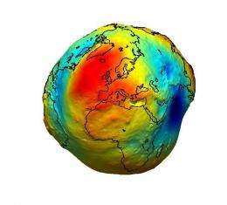Although it has been a crucial term in the history of geodesy and geophysics for about 200 years, it has only recently been precisely defined. It is frequently referred to as the actual shape of the Earth, as opposed to the idealized geometric shape of a reference ellipsoid. Wherever there is a positive gravity anomaly (mass excess), the surface of the Geoid is higher than the ellipsoid, and where there is a negative anomaly, it is lower than the reference ellipsoid (mass deficit). Geoid separation is measured along the ellipsoidal normal as the distance between the geoid and the ellipsoid used as a mathematical reference. Within or outside of the reference ellipsoid, this distance is positive or negative. Geoid undulation is also known as geoidal height. Figure 3.2 shows how geoid surface of the earth.

Figure 3. Geoid (Source: Bob, 2012)

### The Ellipsoid

An ellipsoid, which in geodesy is interpreted to denote a surface of revolution generated by rotating an ellipse about its minor axis, serves as a superior reference surface. Geocentric or local reference ellipsoids are created when ellipsoids with specific geometric qualities are positioned in a way that approximates the global geoid or approximates localized sections of the geoid (Ziggah, 2021). The earth can be regarded as an equipotential ellipsoid of revolution (Li and Götze, 2001). The theory of equipotential ellipsoid was first given by P. Pizzetti in 1894 and was further elaborated by C. Somigliana in in 1929 (Li and Götze, 2001). This theory served as the basis for the international Gravity Formula adopted at the General Assembly of the international Union of Geodesy and Geophysics (IUGG) in Stockholm in 1930 (Li and Götze, 2001). Even though the earth is not an exact ellipsoid, the equipotential ellipsoid provides a simple, uniform, and reliable reference system for all geodesy and geophysics purposes: a reference surface for geometric use, such as map projection and satellite navigation, and a normal gravity field on the Earth and in space, defined in terms of closed formulas as a reference for gravimetry and geodesy (Li and Götze, 2001).

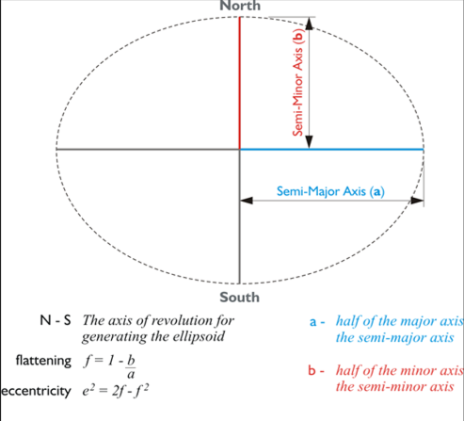The Earth ellipsoid is a mathematical representation of the approximate form of the Earth used in geodesy as a reference point for calculations. The ellipsoid is the mathematical approximation of the earth (Figure 3.3). The semi major axis (a), total mass of the ellipsoid (M), semi minor axis (b), and flattening (f), which indicates the geometric characteristics of the Earth, are the four parameters that characterize the ellipsoid. Axes of the Earth's ellipsoid can be determined using meridian arcs, modern satellite geodesy, or study and interconnection of continental geodetic networks.

Figure 3.3 A Diagram of the Earth's Reference Ellipsoid

The ellipsoid has the following characteristics (Ziggah, 2014):

1. The ellipsoid is an imaginary surface
2. It is described any the semi – major axis and the flattening
3. It cannot be sensed by instrument.
4. The ellipsoid is used as a datum for horizontal positions,

War Office 1926 ellipsoid

The first Geodetic Reference Frame (GRF) for Ghana employed several datums, including the War Office 1926 ellipsoid for the Accra datum and the Clarke 1880 ellipsoid for the Leigon 1977 datum (Yakubu and Kumi-Boateng, 2015). The War Office Ellipsoid, which was recommended by the British War Office, serves as the focal point of Ghana's horizontal datum. Regarding the parameters of the datum-ellipsoid, these datums differ widely. The initial local coordinate system in Ghana used the War Office as its datum, which led to the adoption of many datums there. Since transformation between the two surfaces has not been thoroughly defined, Ghana employs the two datums in response to the need for the usage of GPS, which uses the WGS 1984 as its reference surface for various surveys. The Survey Department, through the Land Administration Project, started the renewal of Ghana's Geodetic Reference Network, which was based on the War Office 1926 ellipsoid and entered international organizations including the committee in the African Reference Frame (AFREF), to use the Global Navigation Satellite System (GNSS) technology (Poku-Gyamfi and Schueler, 2008). The geodetic controls for the local datum were established through conventional techniques such as resection, triangulation, trilateration, and astronomical observations (Dzidefo, 2011). Parameters of ellipsoid (Ghana War Office) are semi-major axis (a) = 6 378 299.996 m; semi-minor axis (b) = 6 356 751.69 m; Inverse flattening = 1/ 296; and feet to meter conversion factor = 0.304799706846 (Yakubu and Kumi-Boateng, 2015).

Transverse Mercator projection is used to calculate the easting and northing coordinates. The intersection of latitude 4 degrees 40 minutes North (4o 40' N) and longitude 1 degree West is the origin of coordinates (1o W).

World Geodetic System 1984 ellipsoid

The World Geodetic System of 1984 (WGS84) is a 3-D Earth-centered reference system created by the old U.S. Defense Mapping Organization, which has now been absorbed into a new agency, the National Imagery and Mapping Agency. It serves as the reference for the Global Positioning System (Yakubu and Kumi-Boateng, 2015). Each GPS satellite sends positional data that allows for the computation of its coordinates on the WGS84 ellipsoid at any given time (Uren and Price). WGS84 is based on a consistent set of constants and model parameters that described the Earth’s size, shape and geometric fields. WGS84 identifies four defining parameters. These are semi-major axis of the WGS84 ellipsoid a = 6378137.0 m, inverse flattening factor of the earth 1/f = 298.2572223563, the nominal mean angular velocity of the Earth (ꞷ) = 7292115 ×10-11 rad/sec and the geocentric gravitational constant GM = 3.986004418 × 1014 m3/sec2.

## **Coordinate System**

The description of the locations of points in relation to one another is one of the essential functions of surveying, and particularly of geodesy. Using coordinates to specify the location is one approach to do this (Ashante, 2018). Coordinate system is essentially an abstract idea that forms the scaffolding for the representation of positions and features and is purely independent of the geometrical objects described by then (Featherstone and Vanicek, 1999). They are necessary for locating locations in space and for representing such locations on maps. An origin, the axes' directions, and a scale which is typically, but not always, the same for each axis are the three components that make up a coordinate system. There are several coordinate systems in use today that are based on various geodetic datums, projections, and reference systems.

Ghilani (2010) agreed that three separate reference coordinate systems are crucial for establishing the locations of places on Earth from satellite measurements. In the "space related" satellite reference coordinate systems, the locations of the satellites at the time of observation are first stated. The orbits of the satellites define three-dimensional rectangular systems. Then, satellite locations are converted into a physically connected to the Earth, three-dimensional rectangular geocentric coordinate system. In order to define a coordinate system, one must specify the:

1. The location of the origin
2. The orientation of the three axis and
3. The parameter that is the Cartesian and Curvilinear which defines the position of the point referred to the coordinate system

### The Geodetic Coordinate System

The geographic coordinates system, sometimes referred to as the geodetic coordinates system, consists of Geodetic Latitude (φ), Geodetic Longitude (λ), and Ellipsoidal Height (h) (Vanicek and Steeves, 1996)**.** The framework for calculating a point's coordinates in relation to the earth is a geodetic system. The most used coordinate system today is the latitude, longitude, and the height system. Latitude and longitude are measured on two planes: the Prime Meridian and the Equator. The geographical coordinates can be defined with reference to the ellipsoid or with reference to the geoid. For the ellipsoidal coordinate (φ, λ, h), the ellipsoid is the reference surface. For the astronomical coordinates **(**φ, λ, H), the geoid is the reference surface.

The modern technology uses the geodetic coordinate system for its operations.The angle between an ellipsoidal normal passing through a location and the equatorial plane, which is positive to the north, is the geodetic latitude (φ) of that point on the surface of the globe (Ziggah, 2014). The latitude measures the angles between the equatorial plane and the reference ellipsoid, which range from -90° to 90°. The angle between the prime meridian (Greenwich meridian) and the meridian plane traversing the location (observer's meridian), positive to the east, is known as geodetic longitude (λ) (Ziggah, 2014). The longitude measures the rotational angle ranging from -180o to 180o between the prime meridian, the measured point, and the ellipsoidal height. Geodetic coordinates are the basis for all mapping systems, and they are also used to store, manage, and interchange spatial data.

### Geocentric Coordinate System

A "terrestrial frame of reference," which permits linking sites physically to the Earth, is required since the goal of GPS surveys is to find points on the surface of the planet. This is done using a geocentric coordinate system as the frame of reference (Yakubu and Kumi-Boateng, 2015). Geocentric coordinate systems are those that have their origin at the center of the Earth's mass (Ziggah, 2021). The origin of the geocentric coordinate system is the geocenter, which is where the X, Y, and Z axes are all located. The Z axis is parallel to the earth's spin axis. As an alternative to 3D cartesian coordinates, which are used to define a 3D position on the surface of the Earth, geocentric coordinates are utilized. For geospatial applications, numerous GNSS devices like the GPS primarily employ these 3D cartesian coordinates. The Earth-Centered Earth-Fixed Cartesian Coordinate System (ECECS) is the cartesian coordinate system utilized by GPS for location (ECEF) (Ziggah, 2021). The ECEF coordinate system is a right-handed cartesian system (X, Y, Z) having its origin and the Earth’s center of mass coinciding. The term "Earth-centered" refers to the fact that the origin of the axis (0,0,0) is situated at the mass center of gravity, which has been identified through many years of monitoring satellite trajectories (Vanicek and Steeves, 1996). The term "Earth-fixed" denotes axes that are fixed in relation to the Earth, that is rotate in lockstep with the Earth. The ECEF coordinates are expressed in a reference system that is related to mapping representations. The ECEF system rotates with the Earth and uses a reference ellipsoid to enable the conversion of latitude, longitude, and ellipsoidal height, making it easier for determining the position of a GPS receiver (Vanicek and Steeves, 1996).

The position of the fiducial station of the reference frame is specified by the space geodesist using these cartesian ECEF coordinates. Geodynamic scientists use it to monitor crustal deformation, while space scientists use it to explain the location of a satellite's orbit (Ziggah, 2021).

## Coordinate Transformation

Converting coordinates from one geodetic reference frame to another is a common task for engineers and surveyors. It therefore becomes necessary to determine parameters that will

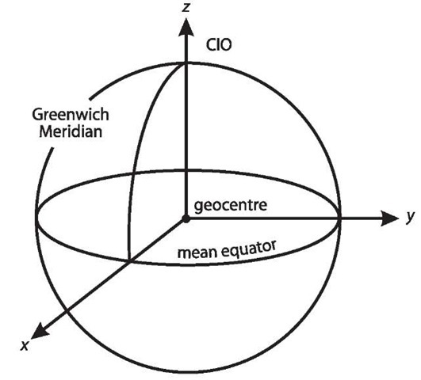mathematically convert data from one geodetic datum to another. The mathematical processes utilized when two or more horizontal and vertical systems are used in the same geographic region, and one needs to transfer the coordinates of points inside the area from one system to another can consequently be termed as coordinate transformation. The least-squares method is used to determine the transformation parameters during the transformation process (Asante, 2018).

Figure 3. 4 The Geocentric coordinate system (Source: Ziggah, 2021)

### Transformation Models and Procedures

To calculate the transformation parameters for the geodetic reference network of nations, there are numerous transformation models available. Abridged Moldensky-Badekas, a ten (10) parameter transformation, 2D and 3D Affine, Bursa Wolf, a seven (7) parameter transformation model, Thomson-Krakiwsky Model, a nine (9) parameter model transformation, and the seven (7) parameter transformation model known as the Helmert transformation are a few of the models commonly used for transformations (Ziggah et al., 2013). The conformal similarity approaches, including Helmert, Bursa-Wolf, and Molodensky-Badekas, are the ones that are most frequently employed among these models for transformation due to how simple they are and how accurate the results are.

The link between two reference systems can be expressed in a variety of ways. The following considerations may affect your decision regarding the best network transformation model:

1. Whether a huge area or a small area will be covered by the model
2. The required accuracy
3. It must be determined if transformation parameters are provided or not
4. The networks’ dimensionality, including whether they are three dimensional (3-D), two (2- D) or one dimensional (1-D)

Bursa – Wolf model

A popular mathematical technique for performing coordinate transformations between two reference frames is the Bursa-Wolf model. Thirty-two dependent Global Positioning System (GPS) Continuously Operating Reference Stations (CORS) in Malaysia were used to produce the Bursa-Wolf, while twenty additional independent neighboring stations were used for assessment. Bursa-seven Wolf's parameters (7p) were computed using RMS at +4.5mm, +9.2mm, and +2.1mm, respectively. The Bursa-wolf model is a frequently utilized geodetic reference frame in deforming regions and one of the realistic mathematical approaches for coordinate transformation (Syetiawan *et al.,* 2019; Abbey and Featherstone*,* 2020). The geometry of the geodetic network holding the coordinates to be converted is retained in this model, therefore angles are not modified after transformation, but the difference in coordinates between the transformed coordinates and their original places may vary (Ziggah *et al.,* 2019). Understanding this coordinate difference is necessary to examine the effectiveness of the Bursa-Wolf model.

# **CHAPTER 4**

# MATERIALS AND METHODS



## **Source of Data**

A coordinate system is established in which each location or topographic feature has a clear set of numbers, making it possible to know with confidence where we are on the Earth or where any feature or station is located or positioned. The term "position" now refers to a collection of coordinates in a well-defined coordinate system (Ayer and Fosu,2008). This study used 38 common point of well-known positions in both the Ghana War Office 1928 and World Geodetic System 1984 ellipsoids from the Survey and Mapping Division (SMD) of the Lands Commission. It is a secondary data in Geographic Coordinate system picked from the current 16 regions in Ghana. This network was established by the Survey and Mapping Division through the Land Administration (LAP) with the sole aim of improving the use of Global Navigation system (GNSS) for land positioning (Poku-Gyamfi and Schueler, 2008).

## **Softwares Used**

The various software’s use for the accomplishment of the project objectives include: Microsoft Excel 365, Visual Studio 2019, ArcGIS 10.8 and MATLAB 2021a.

## **Methods Used**

Figure 4.1 shows the general flow – chart of the work that comprises of three (3) main process which are: coordinate transformation parameter estimations based on Bursa – Wolf, coordinate transformation, and finally assessment of the coordinate difference (Azahar *et.,* 2021). The following subsections explain each process in detail.

**38 SELECTED STATIONS**

WGS84

**Transformation from Geodetic coordinates to cartesian coordinates using Bowring’s forward equation.**

**Coordinate Transformation Parameters Computation using Bursa – Wolf Model.**

7 Parameters (3 Translation, 3 Rotations,

1 Scale)

WAR OFFICE

**Transformation from Cartesian coordinates to Geodetic using Bowring’s reverse equation.**

Transverse Mercator (TM)

**Horizontal Error Check**

Figure 4. Flow Chart of Methods Used

### C-Sharp Language (C#)

C# is an object-oriented programming language based on the C programming language. Developers utilize C-sharp in desktop program development, Web development and service creation, Microsoft application development, game development, and other areas. It may also be used to create mobile applications and cloud-based services. Because of its versatility, it is regarded as a multi-purpose programming language.

### Forward Conversion

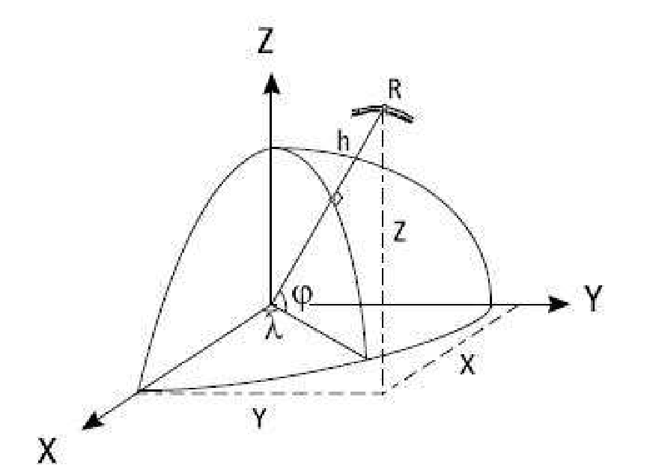The latitude, longitude, ellipsoidal height, and cartesian coordinates are the two primary categories of coordinate systems. The latitudes and longitudes designate points on an ellipsoid whose surface is assumed to roughly suit the earth. A third coordinate, ellipsoid, is introduced since actual locations on the earth lie above (or perhaps below) the ellipsoid surface (Ayer and Fosu, 2008). Figure 4.2 depicts the geometry of ellipsoidal surface.

Figure 4. Ellipsoidal Surface

φ = Latitude,

λ = longitude,

h = height above ellipsoid

Cartesian coordinates use the three perpendicular axes X, Y, and Z to define locations in three dimensions. These can be used instead of the ellipsoid height system, latitude, and longitude. The center of the ellipsoid is where the Cartesian system originated. Any point that can be uniquely defined by latitude, longitude, and ellipsoid height may also be uniquely represented by a set of three-dimensional Cartesian coordinates, and vice versa (Ayer and Fosu, 2008).

The Survey and Mapping Division of the Lands Commission in Ghana provided a secondary data in longitudes, latitudes, and ellipsoidal height in the datum of both WGS84 and War Office 1926 geodetic coordinates for the new Ghana geodetic reference network. Because it is required in most 3D datum transformation parameter determinations, the Bowring forward equation was originally employed to turn geodetic coordinates into cartesian coordinates (Kumi-Boateng and Ziggah, 2016). The Bowring forward equation was used to do a direct transformation of geodetic coordinates (φ, λ, h) over a reference ellipsoid to cartesian coordinates (X, Y, Z). This equation may be written mathematically as:

X = (N + h) cos φ cos λ (4.1)

Y = (N + h) cos φ sin λ (4.2)

Z = (N (1-e2+ h) sin λ (4.3)

Where:

φ = Latitude,

λ = longitude,

f = flattening which measures the difference between the two axes of the ellipsoid,

e =eccentricity of the reference ellipsoid.

h = ellipsoidal height

The radius of the curvature in the prime vertical plane N, and e2 the first eccentricity is given by

N = (4.4) N = the radius of curvature in the prime vertical

a = semi major axis of the reference ellipsoid

### Bursa – Wolf Transformation Model

Global satellite datums are particularly well adapted to the Bursa-Wolf (Bursa, 1962; Wolf, 1963) seven-parameter conformal model for translating three-dimensional Cartesian coordinates between datums (Krakiwsky and Thomson, 1974). The Bursa-Wolf model considers misalignment of the X, Y, and Z axes between two reference systems. That is three rotations, three translations, and a scaling factor, resulting in a seven-parameter transformation technique. The shape of the geodetic network containing the coordinates to be transformed is retained in this model, therefore angles are not modified after transformation, but the distance between the transformed coordinates and their original positions can be changed (Constantin-Octavian, 2006; Ghilani, 2010).

Figure 4.3 displays the geometry of the Bursa-Wolf transformation model. The origins of the two systems are moved by translations tX, tY, and tZ in the directions of the X, Y, and Z axes of system 2, while the X, Y, and Z axes of system 1 are rotated by extremely tiny angles εx, εy, εz from the X, Y, and Z axes of system 2. In both coordinate systems, I1 and I2 are vectors of coordinates, while t is a vector of translations. A vector equation may be used to express the mathematical link between the coordinates in the two systems: I2 = t2 + (1+ ds R I) RS I1 (Kumi-Boateng and Ziggah, 2016).

A different way to write about the Bursa-Wolf transition is: Where (X, Y, Z)2 and (X, Y, Z)1 are the respective rectangular coordinate for War Office 1926 ellipsoid and WGS84 ellipsoid.

Figure 4.3 Geometry of Bursa – Wolf Model

### Reverse Conversion

To enable projection of the coordinate onto the Transverse Mercator that is used in Ghana, the new War office rectangular coordinates obtained after applying the Bursa-Wolf parameters determined need to be transformed back into geodetic coordinates (latitude, longitude, ellipsoidal heights). This will also make it possible to represent the coordinates in the Ghanaian national projected grid coordinate system (Easting, Northing). Bowring Inverse Equation models were used to perform the reverse transformation. (Kumi-Boateng and Ziggah, 2016).

The longitude (λ) is easily computed from

λ = ) (4.5)

Where:

λ = longitude

Y = Y Cartesian coordinates

X = X Cartesian coordinates

The dependence of N on φ makes the reverse/inverse translation from cartesian to geodetic coordinates slightly more challenging. Researchers have created models to compute the geodetic latitude more quickly in this case. Nevertheless, the Bowring Inverse technique is also quick enough for most actual applications (typically, only two iterations are needed to reach mm-accuracy), and with modern processors, the pace of convergence is not a problem (Ziggah, 2021).

### Bowring Inverse Equation

The iterative process Bowring (1976) provided has been referred to as a basis upon which other approaches have been built. The meridian ellipse is depicted in Figure 4.4. Point P is the point's position, and P" is the point that corresponds to it and is situated where the ellipsoid and spheroidal normal cross. M is the meridian's radius of curvature, and C is the elliptical meridian's center of curvature.

f

z

x

P

C

P"

M

h

Figure 4. 4 Relationship between the Center of the Curvature and the Meridian.

Since there is no practical need for a second or third iteration, this iterative procedure can be regarded as precise due to the nature of the equation utilized (Bowring 1976, p.326).

From the ellipsoid relationships, perpendicular distances from C (the centre of curvature of the meridian ellipse) to the Z- and OM-axes are e’2 acos3ψ and -e’2bsin3ψ respectively, thus an expression for tan φ in terms of the parametric latitude ψ is

(4.6)

Where:

Ѱ = Parametric latitude

a = semi-major axis of the reference ellipsoid

b = semi-minor axis of the reference ellipsoid

p = is the perpendicular distance from the rotational axis

is the first eccentricity

= is the second eccentricity.

This equation having functions φ on both sides of the equation, obviously needs an iterative solution for tan φ. The initial value, ψ0 was obtained from the relationship between the geocentric and parametric latitude using

tanѱ0= (4.7)

Bowring (1976) shows that for all Earth-bound points (-5 000*m* ≤ h ≤ 10,000m) the maximum error in φ,induced by using only a single iteration, is 0.000 000 030′′. Thus, for all practical purposes, the evaluation of tan φ by (4.6), with a first approximation of ψ from (4.7), can be regarded as exact. Once the latitude (φ) is known, the ellipsoidal height, h, can be computed according to the following equation

h = (4.8)

### Transverse Mercator Projection

A map projection is a way to represent (flatten) the 3D surface of the Earth on a 2D plane for cartography or display. The Transverse Mercator Projection is the map projection accepted in Ghana for mapping. This results from projecting the globe onto a cylinder tangent to a central meridian resulting in s mesh of longitude and latitude lines superimposed on its plane surface when cut opened (Ayer and Fosu, 2008). All map projections distort the surface in some fashion, and no singlet projection is the best for all purposes or in all the regions. In general, map projections are the to preserve at least one property from area, shape, direction, bearing, distance, and/or scale. When performing a map projection, geographic coordinates (latitude/longitude) are turned into cartesian, or polar, plane coordinates (y/x or northing/easting). The formula for the Transverse Mercator projection is given below:

Projection parameters

Knowledge of the datums and projection parameters is necessary before these formulars can be used.

a Semi – major axis of reference ellipsoid

f -1 Inverse ellipsoidal flattening

φ0 Origin latitude

λ0 Origin longitude

N0 False Northing of projection

E0 False Easting of the projection

k0 Central meridian

φ Latitude of the computation

λ Longitude of the computation point

N Northing ordinate of computation point

E Easting ordinate of computation point

M Meridian

Projection constants

Several additional parameters, b, e2, m0, need to compute before transformation can be taken. These parameters are constant for a projection.

f -1 = 1/f (4.9)

b = a(1-f) (4.10)

e2 = 2f – f2  (4.11)

m = a (A0 φ – A2sin2 φ + A4sin4 φ – A6sin6 φ) (4.12)

where:

A0 = 1 – () – () – () (4.13)

A2 = () (4.14)

A4 = (4.15)

A6 =

m0 is obtained by evaluating m using φ0

Geographic coordinated to Transverse Mercator projection (TM)

The conversion of geographic coordinates (φ, λ) to projection coordinates (N, E) is achieved is several steps. These are:

Determine m, p, v and

*P* = (4.16)

v = (4.17)

*ѱ* = (4.17)

t = tan φ (4.18)

w=λ–λ0 (4.19)

Determine the projection northing (N) of the computation point using:

N = N0 + k0 (m – m0 + Term1 + Term2 + Term3 + Term4) (4.20)

Where;

Term1 = (4.21)

Term2 = ) (4.22)

Term3 = (4.23)

Term4 = ) (4.24)

Determining the projection easting (E) of the computation point using;

E = E0 + k0 vwcos φ (1+Term1 + Term2 + Term3) (4.25)

Where:

Term1 = (4.26)

Term2 = (4.27)

Term3 = (4.28)

### Software and the Model Performance criteria

The result given out by the software and the strength of the Bursa Wolf model was assessed by computing the horizontal accuracies. The evaluation of the performance was accomplished by using performance criteria indicators (PCIs) such as Horizontal Positional shift or Horizontal Error (HE), Root Mean Square Horizontal Error (RMSHE), Standard Deviation (RMS), and Arithmetic Mean of the Horizontal Error (AMHE) (Ziggah *et al.,* 2019a). Equations are as follows:

HE = =

and denotes Known Eastings and Northings. and denotes computed values of the software for Northings and Eastings.

RMSHE=

Where;

n is the number of observation and i= 1…. n.

AMHE=

SD = , where n – 1 is the degree of freedom

The Standard Deviation measures how closely the data are clustered about the mean and the RMS gives a sense of typical size of the value.

# **CHAPTER 5**

# RESULTS AND DISCUSSION



## **Software Architecture**

The focus of this project was to design a computer software which will make users comfortable in computing coordinate from the common coordinate system latitudes, longitudes, and ellipsoidal height to the Ghana’s Transverse Mercator Projection. The figures below are the software User Interface.

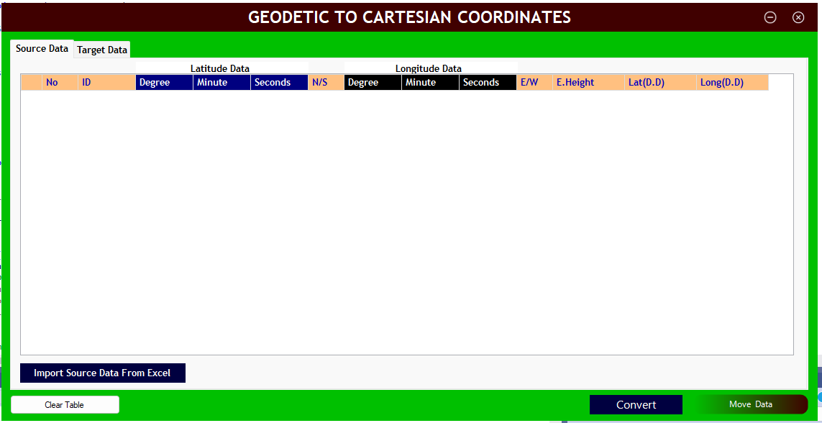Figure 5.1 shows the ground or the first interface of the software to upload or take in data. The software is designed in such a way that it takes in data with eighteen parameters. Nine parameters for the source data and nine parameters for target data. The ID parameter is common for all the two types of the data and each of the dataset contains degree, minute, seconds, and directions that is each for latitude, longitude data respectively and ellipsoidal height. To upload data into the software, the button named import source data from excel where the arrow is pointing to must be pressed to be able to navigate to where you saved you excel.

Figure 5. 1 Software Ground Interface to upload data

Import

Figure 5.2 shows the Graphical User Interface (GUI) with the uploaded data, the clear button is used to erase data from the DataGrid view if a new dataset is to be uploaded or a wrong dataset already uploaded is to be erased and a new one uploaded. The Convert button is used to convert data from the degrees, minutes, and seconds to decimal radians. The move data button passes the converted values to the next form to continue computation.

Figure 5.3 shows the snap short, passed data of the source and target ready for conversion. Before the conversion is done, the ellipsoidal references of the various datums of the target and the source that is the semi major axis, and the inverse flattening is input in the text area as indicated in the GUI. The software then uses this input parameters to compute other parameters such as semi minor axis, first eccentricity, second eccentricity as mentioned earlier since they all depend on the major axis and inverse flattening and uses these computed parameters to compute the transformational parameters and give out cartesian coordinate as output result by just a click on the compute button.

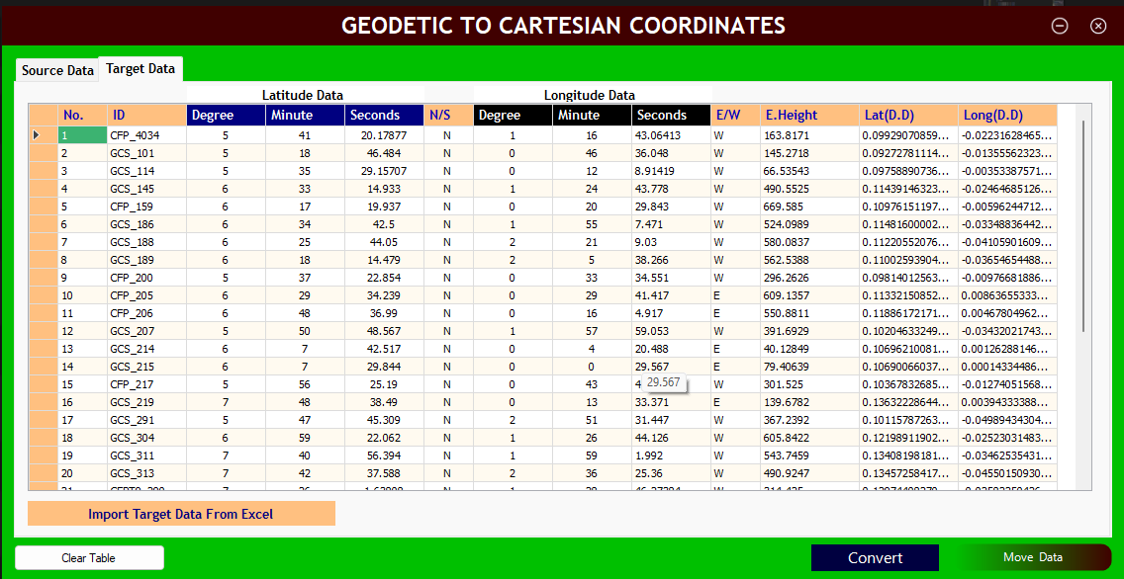

**Clear**

**Convert**

Figure 5.2 GUI Showing uploaded Latitude, Longitude, and ellipsoidal height data

**Move data**

**Move data**

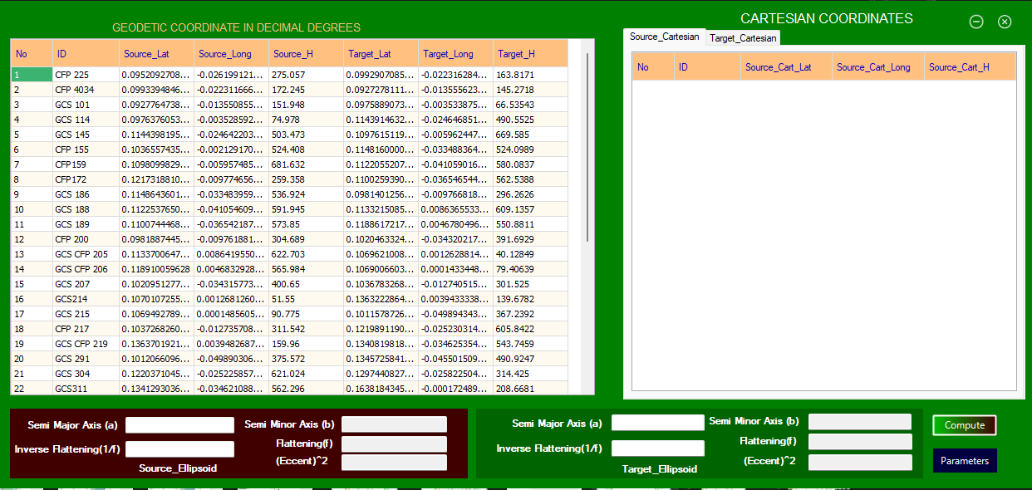

Compute

**Semi major axis**

**Inverse flattening**

**Inverse flattening**

**Semi major axis**

Figure 5. 3 GUI for Forward Conversion

Figure 5.4 shows the GUI containing the transformation parameters and the reverse conversion data that is the cartesian to local geodetic data, the parameters used are also indicated in the text field for clearer and easier explanation and understanding on how the software was designed and its functionality. This computer application is designed to be able to transform coordinate from other countries if some few parameters of the country such as the major axis and the inverse flattening are known; the software also provides a field that enables user to input the parameters for transformation. In computing for the cartesian to geodetic coordinates, the user first input the country of target ellipsoidal parameters of semi major axis and inverse flattening and with the just a click on the Compute button, the other parameters are computed and with a click on the Fill Table button, it automatically calculates the cartesian to geodetic coordinates for the user. Clicking on the arrow button direct user to another form as shown below.

**Cartesian to Geodetic coordinate**

**Transformation Parameters**

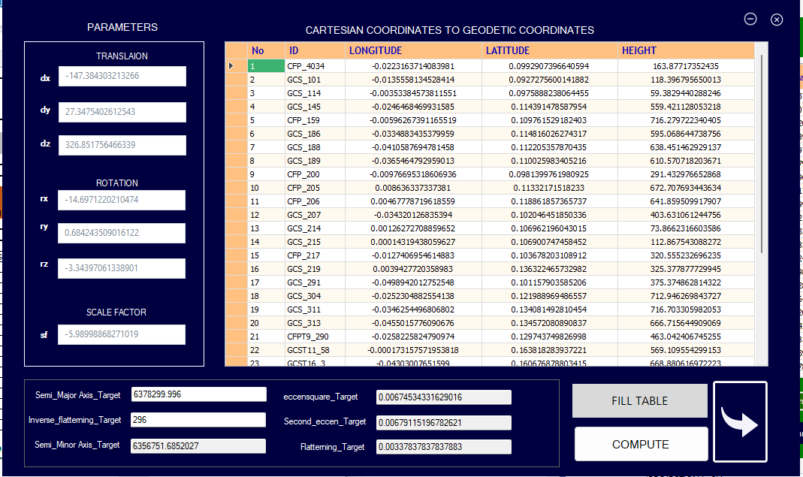

Figure 5.4 GUI of Transformation Parameters and Geodetic to Cartesian Coordinate

Figure 5.5 shows the final GUI of this computer application, and it contains the Transverse Mercator projection coordinates as shown. Pressing or clicking on the project button will project the local geodetic coordinate to the Transverse Mercator projection hence creating the grid for Ghana. Clicking on the XLS icon will export all the projected data into an excel format and clicking on the PDF icon will generate a PDF format of the projected data for the user.

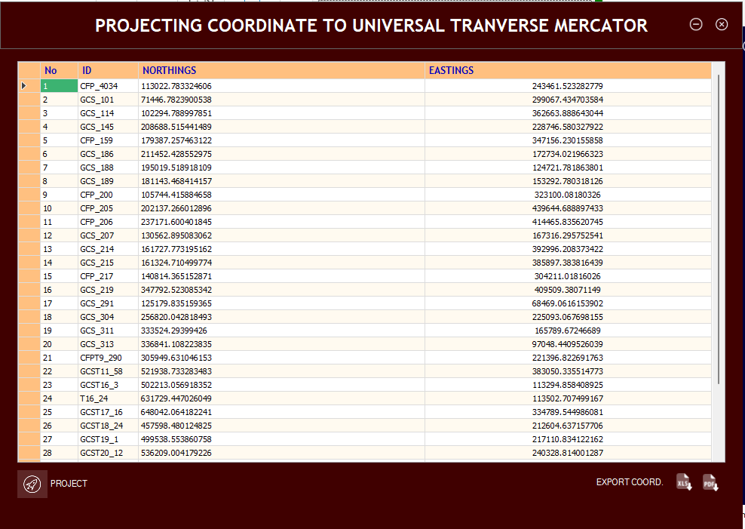

**Project**

XLS

**PDF**

Figure 5.5 GUI view for Projection of Coordinate to Transverse Mercator

## **Data Results**

As mentioned in the earlier chapters, 38 data of format latitude, longitude and ellipsoidal height data was picked across the country shown in Table 5.2 but since this software makes use of common data from both datums, 34 data was used in the transformation process. One of the objectives of this project apart from creating the software was to perform a coordinate transformation. The result obtained from the various computation during the transformation process are shown in Table 5.2.

Table 5. Cartesian Coordinates from WGS84 and War Office Ellipsoid

|  |  |  |  |  |  |  |
| --- | --- | --- | --- | --- | --- | --- |
|  | **WGS(m)** | | | **WAR OFFICE 1926(m)** | | |
| **Id** | **Xm** | **Ym** | **Zm** | **Xm** | **Ym** | **Zm** |
| CFP_4034 | 6345492.683 | -141602.016 | 628362.4372 | 6345678.028 | -141635.47 | 628038.0514 |
| GCS_101 | 6350457.508 | -141602.016 | 586967.8071 | 6350642.679 | -86092.193 | 586645.2009 |
| GCS_114 | 6347996.448 | -22399.5829 | 617621.721 | 6348181.759 | -22433.779 | 617298.0631 |
| GCS_145 | 6335269.772 | -156146.614 | 723534.0899 | 6335455.178 | -156180.65 | 723209.812 |
| CFP_159 | 6340540.971 | -37774.1259 | 694399.7979 | 6340726.419 | -37806.694 | 694075.5117 |
| GCS_186 | 6333367.167 | -212145.501 | 726210.4799 | 6333552.552 | -212179.64 | 725886.1305 |
| GCS_188 | 6333507.205 | -260165.851 | 709780.3968 | 6333692.356 | -260201.41 | 709457.2339 |
| GCS_189 | 6336129.71 | -231639.156 | 696053.7173 | 6336315.058 | -231673.58 | 695729.2495 |
| CFP_200 | 6347620.739 | -61966.6909 | 621119.5992 | 6347806.001 | -61999.843 | 620796.355 |
| CFP_205 | 6337846.027 | 54772.7439 | 716812.7211 | 6338031.66 | 54740.1095 | 716487.2501 |
| CFP_206 | 6333888.816 | 29663.67301 | 751675.9322 | 6334074.426 | 29631.3307 | 751350.912 |
| GCS_207 | 6341808.253 | -217709.518 | 645757.6824 | 6341993.602 | -217744.1 | 645432.7378 |
| GCS_214 | 6341941.187 | 8042.385015 | 676698.1249 | 6342126.685 | 8009.35848 | 676373.3478 |
| GCS_215 | 6342026.789 | 942.1749007 | 676315.1989 | 6342212.279 | 909.123544 | 675990.4726 |
| CFP_217 | 6343878.761 | -80798.1571 | 656033.0282 | 6344064.064 | -80831.021 | 655709.6238 |
| GCS_219 | 6319422.447 | 24950.90786 | 861364.7648 | 6319608.206 | 24920.4544 | 861039.489 |
| GCS_291 | 6338194.217 | -316477.069 | 640154.1209 | 6338379.428 | -316511.97 | 639829.7281 |
| GCS_304 | 6329616.953 | -159703.894 | 771354.8432 | 6329802.305 | -159736.8 | 771031.608 |
| GCS_311 | 6317996.787 | -218823.364 | 847348.2852 | 6318181.876 | -218856.76 | 847027.187 |
| GCS_313 | 6314774.655 | -287505.105 | 850422.039 | 6314959.697 | -287538.66 | 850101.0261 |
| CFPT9_290 | 6323065.512 | -163284.964 | 820069.479 | 6323250.736 | -163318.47 | 819747.4012 |
| GCST11_58 | 6293490.41 | -1055.79188 | 1033649.179 | 6293676.022 | -1085.5923 | 1033326.002 |
| GCST16_3 | 6290997.233 | -270843.268 | 1014022.47 | 6291182.366 | -270875.51 | 1013701.753 |
| T16_24 | 6269003.759 | -270252.246 | 1141652.201 | 6269188.881 | -270283.07 | 1141332.172 |
| GCST17_16 | 6271639.213 | -48945.799 | 1158015.78 | 6271824.738 | -48975.361 | 1157693.671 |
| GCST18_24 | 6301262.817 | -171698.37 | 970198.9151 | 6301448.125 | -171730.26 | 969877.1677 |
| GCST19_1 | 6294815.682 | -167078.017 | 1011637.77 | 6295001.041 | -167109.1 | 1011315.995 |
| GCST20_12 | 6289407.922 | -143756.861 | 1047853.76 | 6289593.305 | -143787.34 | 1047532.057 |
| GCST20_23 | 6276319.39 | -261074.175 | 1103221.12 | 6276504.563 | -261104.91 | 1102900.76 |
| GCST21_33 | 6292490.636 | -91622.002 | 1035513.63 | 6292676.107 | -91652.04 | 1035191.378 |
| GCST23_3 | 6263051.628 | -269718.43 | 1173507.499 | 6263236.733 | -269749.31 | 1173187.598 |
| GCST23_14 | 6260415.773 | -228527.401 | 1196135.822 | 6260598.749 | -228558.06 | 1195815.397 |
| GCST24_1 | 6309383.23 | -56777.817 | 930396.787 | 6309568.74 | -56807.765 | 930073.7812 |
| GCST19_29 | 6264023.925 | -159878.713 | 1188012.741 | 6264209.177 | -159908.91 | 1187692.193 |

The result in Table 5.3 depicts the parameters obtained during the transformation process.

Table 5. Parameters from Bursa Wolf Transformation Model

|  |  |  |  |
| --- | --- | --- | --- |
| **Transformation Parameters** | **Symbols** | **Values** | **Units** |
| TRANSLATIONAL PARAMETERS | TX | -147.3843032 | arc second |
| TY | 27.34754026 |
| TZ | 326.8517565 |
| ROTATIONAL PARAMETERS | RX | -14.69712202 | Meters |
| RY | 0.684243509 |
| RZ | -3.343970613 |
| SCALE FACTORS | Sc | -5.989988683 | Part per million |

The Bursa Wolf transformation model possess the ability to match or adjust and transform dataset to the other.

### Revise Conversion and Projected Coordinates

The computed or generated parameters were used then to make the local non-geocentric coordinate geocentric by reverse conversion. These computed values serve as the foundation to be able project the coordinates onto grid coordinates using the Transverse Mercator projection. These geocentric coordinates were generated because of combining the common data from WGS84 and War Office 1926. From Table 5.3 The Bursa-Wolf transformation model produced the highest positional shift of 4 m and the least positional shift of -0.04 m in the Northing. It also yielded a highest positional shift of 3 m and the least being -0.06 m in the Easting. The result of the transformed coordinates with their error differences are shown in Table 5.4.

|  |  |  |  |  |  |
| --- | --- | --- | --- | --- | --- |
| **Known_Nm** | **Known_Em** | **Computed_N** | **Computed_E** | **Error_Nm** | **Error_Em** |
| 113022.7 | 243461.4572 | 113022.7833 | 243461.5233 | -0.049748997 | -0.066058125 |
| 71448.38 | 299068.0215 | 71446.78239 | 299067.4347 | 1.59425945 | 0.586807107 |
| 102295.3 | 362663.0813 | 102294.789 | 362663.8886 | 0.528039304 | -0.80732959 |
| 208688.4 | 228745.9377 | 208688.5154 | 228746.5803 | -0.10229239 | -0.642637995 |
| 179387.1 | 347157.0363 | 179387.2575 | 347156.2302 | -0.108812294 | 0.80615119 |
| 211452.3 | 172733.2644 | 211452.4286 | 172734.022 | -0.167862123 | -0.75759584 |
| 195020.6 | 124719.6143 | 195019.5189 | 124721.7819 | 1.074920593 | -2.167514161 |
| 181143.2 | 153291.7339 | 181143.4684 | 153292.7803 | -0.280260274 | -1.04637693 |
| 105745.4 | 323100.3232 | 105744.4159 | 323100.0818 | 0.94732227 | 0.241401349 |
| 202136 | 439645.4837 | 202137.266 | 439644.6889 | -1.272369731 | 0.794838942 |
| 237170.8 | 414466.8517 | 237171.6004 | 414465.8356 | -0.815934871 | 1.016060243 |
| 130562.1 | 167315.1173 | 130562.8951 | 167316.2958 | -0.751936721 | -1.178402926 |
| 161727.2 | 392996.5835 | 161727.7732 | 392996.2084 | -0.594591111 | 0.375173504 |
| 161324.2 | 385897.7191 | 161324.7105 | 385897.3838 | -0.547212106 | 0.33531012 |
| 140815.1 | 304211.5379 | 140814.3652 | 304211.0182 | 0.782932209 | 0.519739436 |
| 347791.4 | 409512.302 | 347792.5231 | 409509.3807 | -1.098004444 | 2.921254746 |
| 125180 | 68467.52086 | 125179.8352 | 68469.06162 | 0.136475507 | -1.540754922 |
| 256821 | 225093.535 | 256820.0428 | 225093.0677 | 0.916621095 | 0.467296624 |
| 333527.4 | 165789.6009 | 333524.294 | 165789.6725 | 3.086973685 | -0.071554046 |
| 336844.4 | 97048.25714 | 336841.1082 | 97048.44095 | 3.316513803 | -0.183812867 |
| 305951.7 | 221396.7047 | 305949.631 | 221396.8227 | 2.102867836 | -0.117997401 |
| 521939.7 | 383053.9257 | 521938.7333 | 383050.3355 | 0.961374957 | 3.590154925 |
| 502216.5 | 113296.0078 | 502213.0569 | 113294.8584 | 3.475429673 | 1.149439851 |
| 631733.6 | 113505.2803 | 631729.447 | 113502.7075 | 4.152569462 | 2.572780333 |
| 648044.1 | 334793.3757 | 648042.0642 | 334789.545 | 2.016949975 | 3.83070824 |
| 457600.9 | 212606.144 | 457598.4801 | 212604.6372 | 2.416014173 | 1.50683135 |
| 499540.9 | 217113.1472 | 499538.5539 | 217110.8341 | 2.379604637 | 2.313028093 |
| 536211.5 | 240331.7312 | 536209.0042 | 240328.814 | 2.44602475 | 2.917161513 |
| 592642.8 | 122812.6015 | 592638.9347 | 122809.9362 | 3.816021748 | 2.665233744 |
| 523684.9 | 292498.9721 | 523682.9756 | 292495.6167 | 1.89243168 | 3.355416941 |
| 664142.4 | 113933.9384 | 664138.1511 | 113931.4182 | 4.280127449 | 2.520188478 |
| 686997.5 | 155081.1917 | 686993.3815 | 155078.529 | 4.150981393 | 2.662672062 |
| 417340.2 | 327624.3311 | 417339.0252 | 327620.8876 | 1.148939995 | 3.443590375 |
| 678567.3 | 223774.3802 | 678563.7064 | 223771.1756 | 3.596538188 | 3.204504896 |

Table 5.4 Projected Coordinates and Known Coordinates with their Errors

## **Model Adequacy Assessment**

The computed Root Mean Square Horizontal Error (RMSHE), Arithmetic Mean of the Horizontal Error (AMHE) and Standard deviation results are indicated in the deviation of Table 5.5.

Table 5. Summary Statistic Results

|  |  |
| --- | --- |
| **Criteria** | **Value (m)** |
| RMSHE | 2.89365802 |
| AMHE | 2.458279232 |
| SD | 2.50194001415995E-09 |

In Table 5.5, a total uncertainty of 2.89365802 m was achieved. The Bursa wolf model also produced an average horizontal uncertainty of 2.458279232 m. The standard deviation value of 2.50194001415995 x 10-9 m presents the precision level of the Bursa Wolf model computed with respect to the known coordinates. This means that the dispersion of the transformation results from the most probable value is 2.50194001415995 x 10-9 m, which shows a very high precision.

# **CHAPTER 6**

# CONCLUSIONS AND RECOMMENDATIONS



## **Conclusions**

The following conclusions may be drawn from the project's aims and the outcomes;

1. A 3D coordinate transformation between War Office 1926 and WGS84 datums was successfully carried out using the Bursa Wolf transformation Model.
2. A software for the 3D transformation has successfully been built.
3. Additionally, the converted coordinates were successfully projected to Ghana's Transverse Mercator projection.
4. Bursa Wolf model performance has been statistically evaluated with satisfactory results.

## **Recommendations**

Based on the results and the conclusions presented in this project, it is recommended that;

1. Different transformation models should be integrated into the program to enhance its functionality and make it more useful for all geodesy experts and those working in the mining industry, and students who need to utilize the software.

# **REFERENCES**

Abbey, D. A., & Featherstone, W. E. (2020). “Comparative Review of Molodensky-Badekas and Bursa-Wolf Methods for Coordinate Transformation.” Journal of Surveying Engineering, 146pp.

Asante, E. (2018), “Application of RANSAC Algorithm in Horizontal Coordinate Transformation”, Unpublished BSc Thesis, University of Mines and Technology, Tarkwa, 53 pp.

Ayer, J. and Fosu, C. (2008), “Map coordinates referencing and the use of GPS datasets in Ghana”, Journal of Science and Technology, KNUST, Kumasi, Vol. 28, No. 1, pp. 116 – 123.

Baabereyir, A. (2009). “Urban environmental problems in Ghana: case study of social and environmental injustice in solid waste management in Accra and Sekondi-Takoradi. Thesis submitted to Department of Geography, University of Nottingham for the Degree of Philosophy, UK, 97.

Bowring, B. R. (1985), “The Accuracy of Geodetic Latitude and Heights Equations”, Survey Review, 28(218), pp. 202 – 206.

Constan-Octavian, A. (2006). “3D Affine coordinate transformations.” Master of Science Thesis in Geodesy No. 3091 TRITA-GIT EX 06-004, School of Architecture and the Built Environment, Royal Institute of Technology (KTH), 100 44 Stockholm, Sweden.

Featherstone, W. and Vanicek, P. “The Role of Coordinate Systems, Coordinates and Heights in Horizontal Datum Transformations.” The Australian Surveyor, Vol. 44, No. 42, p. 143-149.

Ghilani, C. D. (2010). “Adjustment Computations: Spatial Data Analysis. 5th Edition. John Wiley and Sons Inc., Hoboken, New Jersey, USA.

J., Uren and W., Price (2006), “Surveying for Engineers: 4th edition”, Palgrave Macmillan, London, 824pp.

Kumi-Boateng, B. and Ziggah, Y. Y. (2020) “A 3D Procrustean Approach to Transform WGS84 Coordinates to Ghana War Office 1926 Datum”, Ghana Mining Journal, Vol. 20, No. 1, pp. 1 – 10.

Li X. and Götze, H. J. (2001), “Ellipsoid, geoid, gravity, geodesy and geophysics”, Geophysics, 66(6), pp. 1660 – 1668.

Mitsakaki, C (2004), “Coordinate Transformations”, FIG Working Week, Athens.

Mugnier, J. C. (2000), “OGP – coordinate conversions and transformations including formulae. Column, Grids and Datums. The Republic of Ghana”, Photogrammetric Engineering and Remote Sensing, pp. 695 – 697.

Poku-Gyamfi, Y. (2009), “Establishment of GPS Reference Network in Ghana,” PHD Dissertation, Universitat der Bundeswehr Munchen Germany, pp. 1-177.

Poku-Gyamfi, Y. and Schueler, T. (2008), “Renewal of Ghana’s geodetic reference network”, In 13th FIG Symposium on Deformation Measurement and Analysis, 4th IAG Symposium on Geodesy for Geotechnical and Structural Engineering, LNEC, LISBON, pp. 1-9.

Smith, J. R. (1997), “Introduction to Geodesy”, The history and the concepts of modern Geodesy, John Willey & Sons, New York pp. 83.

Syetiawan, A., Ramdani, D., Safii, A. N., Ardhitasari, Y., Gaol, L., & Annuriah, I (2019), “Development of Parameter Transformation of Indonesian Geospatial Reference System 2013”, The 1st International Conference on Geodesy, Geomatics, and Land Administration 2019, KnE Engineering, pp. 77-94.

Vanicek, P. and Featheratone, W.E (1996), “Transformation of Coordinates between Two Horizontal Geodetic Datum”, Journal of Geodesy, pp. 740 – 745.

Vanicek, P. and Featheratone, W.E (1996), “Transformation of Coordinates between Two Horizontal Geodetic Datum”, Journal of Geodesy, pp. 740 – 745.

Vanicek, P., & Steeves, R. R. (1996). “Transformation of coordinates between two horizontals geodetic datums.” Journal of Geodesy, 70(11) pp. 740-745.

Wolf, H. (1963), “Reports on Triangulation Networks in Ghana, Geometric connection and re-orientation of the three-dimensional triangulation nets”, Survey Records, No. 68, pp. 165 – 169.

Yakubu, I., & Kumi-Boateng, B (2015), “Ramification of datum and ellipsoidal parameters on post processed differential global positioning system (DGPS) data – A case study”, Ghana Mining Journal, 15, 1-9.

Ziggah et al., (2019), “Coordinate transformation between global and local data based on artificial neural network with K-fold cross-validation in Ghana”, Earth Sciences Research Journal, Vol. 23 No. 1, pp. 66-77.

Ziggah, Y. Y. (2014), “Principles of Geodesy”. Unpublished BSc Lecture Notes, University of mines and technology, Tarkwa, 145pp.

Ziggah, Y. Y. (2016), “Principles of Geodesy”. Unpublished BSc Lecture Notes, University of mines and technology, Tarkwa, 200pp.

Ziggah, Y. Y. (2021), “Advanced of Geodesy”. Unpublished BSc Lecture Notes, University of mines and technology, Tarkwa, 176pp.

Ziggah, Y. Y., Youjian, H., Tierra, A. R., & Laari, P. B. (2019a). “Coordinate transformation between global and local data based on artificial neural network with K-fold cross-validation in Ghana”, Earth Sciences Research Journal, Vol. 23 No. 1, pp. 66-77.

Ziggah, Y.Y., & Laari, P.B. (2018). “Application of Multivariate Adaptive Regression Spline (MARS) Approach for 2D Coordinate Transformation.” Ghana journal of technology, 2(2), 50-62.